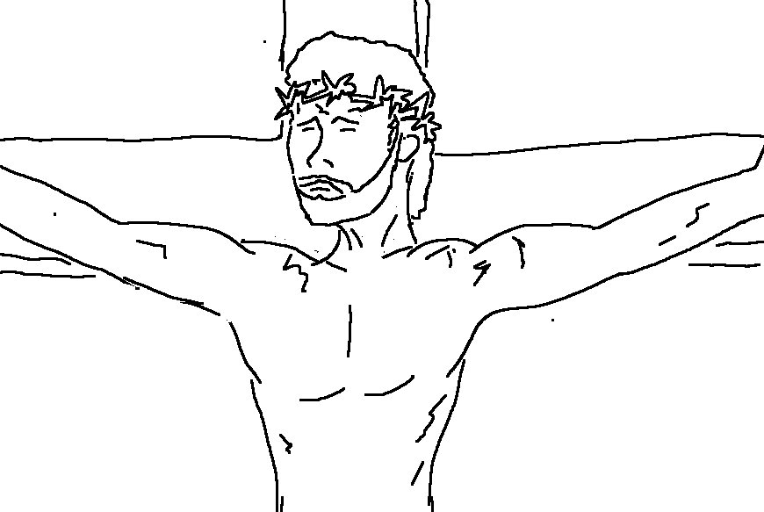
Look! The Lamb of God who takes away the sin of the world! John 1:29_{NLT}

